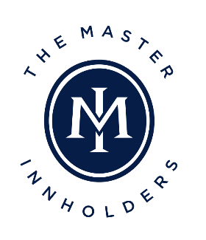
Moët & Chandon Educational Tour
6th & 7th July 2022

Applicants Name
Applicants Hotel
Job Title
Age
Preferred Email Address

Preferred telephone number

Brief Career History

Reason for applying (150 words maximum)

General Manager’s comments (150 words maximum)

By signing this application form the General Manager is agreeing to release the applicant for the period of the Educational Tour and to financially support the applicant’s travel expenses to and from Paris Charle de Gaulle airport.
General Manager’s
Signature

Print General Manager’s Name

Date

Applications must be received by Friday 29th April 2022 and should be emailed to Wallace Vincent, the Executive Secretary of the Master innholders at wvincent@masterinnholders.co.uk

